PARUL UNIVERSITY
FACULTY OF ENGINEERING AND TECHNOLOGY

PARUL INSTITUTE OF TECHNOLOGY

Department of Computer Science & Engineering


LAB MANNUAL

(EVEN SEMESTER)

SUBJECT CODE: 03105256
SUBJECT NAME: Prototype Designing
YEAR/SEM: 4th sem
DEPARTMENT: CSE
A

REPORT
on
SOCIAL WAR

Submitted by

NAME : RAHUL VERMA 150305105080
NAME : DHERYA SHAH 150305105086
NAME : MEET SHAH 150305105088
NAME: PANAKJ SHAH 150305105091

BACHELOR OF ENGINEERING

IN

COMPUTER SCIENCE & ENGINEERING

Under the

Guidance of

Mr. CHANDAN TRIVEDI

(Asst. Professor, CSE)



JUNE 2017
FACULTY OF ENGINEERING TECHNOLOGY

(PARUL UNIVERSITY)
VADODARA (GUJARAT)
PARUL INSTITUTE OF ENGINEERING AND TECHNOLOGY


CERTIFICATE

This is to certify that Mr.. Rahul, Dherya, Meet, Pankaj with enrolment no. ( 080, 086, 088, 091 ) has successfully completed his laboratory experiments in Prototype Designing (03105256) during the academic year 2016-2017.

Date: Signature Teacher: Mr. Chandan Trivedi.

Signature of HOD: Signature
ACKNOWLEDGEMENT

It gives me immense pleasure to express my deepest sense of gratitude and sincere thanks to my highly respected and esteemed guide ……(name of guide with deptt. name)…, PIT, PU Vadodara, for their valuable guidance, encouragement and help for completing this work. Their useful suggestions for this whole work and co-operative behavior are sincerely acknowledged.
I would like to express my sincere thank to MR. Chandan Trivedi, PU, Vadodara for giving me this opportunity to undertake this project. I would also like to thank Dr. Shital Shah, principal for whole hearted support.
I also wish to express my gratitutes to MR. Shailendra Mishra, HOD (COMPUTER SCIENCE & ENGINEERING) for his kind hearted support. I am also grateful to my teacher MISS Payal desai for their constant support and guidance.
I also wish to express my indebtedness to my parents as well as my family member whose blessings and support always helped me to face the challenges ahead.
At the end I would like to express my sincere thanks to all my friends and others who helped
me directly or indirectly during this project work.

Place: Vadodara
Date:

Abstract
This project is based on today situation .our project is for entertainment purpose
For photogenic person and who love to upload photographs on social site
Like facebook, instagram and other social networking sites or apps.
So we introduce different software in which there will be war between to
Contents tent they upload photograph and chance to win the war.
Or social war. And we also provide facility to expert photographer
They can buy and use the photographs which they like by
The legal agreement between the customer and photograph.
And the normal people chance to win gifts and coupons, or other
Excitement offers.

Table of Contents
CHAPTER-1 Introduction 9
1.1 Problem Definition 9
1.2 Purpose 9
1.3 Scope 9
1.4 Overview 9
CHAPTER-2 Requirements Engineering 10
2.1 Requirements Elicitation (Requirements Gathering) 10
2.2 Requirements Analysis 13
2.2.1 Context Diagram 13
2.2.2 Develop Prototype 14
2.2.3 Model and Finalized the Requirements 17
Level 0: Context level diagram 17
2.3 Requirements Documentation and Requirements Review 19
CHAPTER 3 Conclusion and Future Scope 20
Referrences 21
Appendix 22

List of Figures

List of Tables

CHAPTER-1 Introduction

The following subsections should provide an overview of the entire system.

1.1 Problem Definition
Give proper definition of your system.
  - Purpose
Identify the purpose of your system and its intended audience. Describe the motivation for your system.
  - Scope
Explain what the software will, and, if necessary, will not do. Describe the application of the software being specified, including relevant benefits, objectives and goals.
  - Overview
Describe what the rest of the document contains.

CHAPTER-2 Requirements Engineering

Requirements describe the “What” of a system not “How”. Requirements engineering produces one large document, written in a natural language, contains a description of what the system will do without describing how it will do. The input to requirements engineering is the problem statement prepared by the customer.

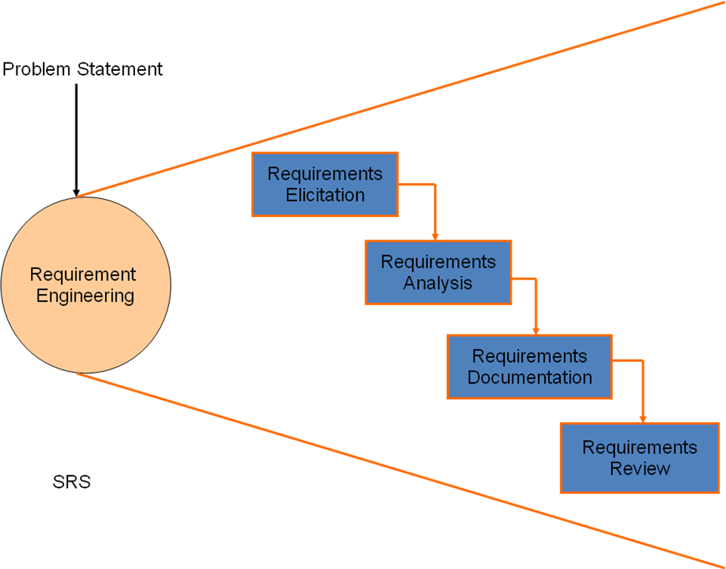
Fig. 2.1 Requirements Engineering Phase
  - Requirements Elicitation (Requirements Gathering)
Here, requirements are identified with the help of customer interaction and existing system processes, if available. It is the activity that helps to understand the problem to be solved. Requirements are gathered by asking questions, writing down the answers, asking other questions, etc. Hence, requirements gathering is the most communications intensive activity.

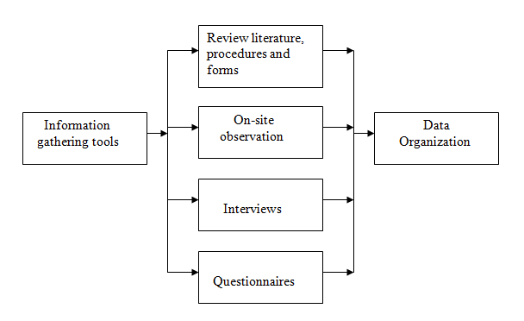
Fig. 2.2 Information gathering Process
There are different methods available for Requirements Gathering:
- Interviews
Arrange meeting with customers. Ask different questions to customers related to system.
- Brainstorming Session
The group discussions between developer and customer can lead to new ideas quickly.
- The Use Case Approach
For many years, requirement engineers have used stories and scenarios to explain the interaction of a user with the proposed system in order to gather requirements.
In 3rd Semester, students have already completed these tasks through AEIOU framework and Empathy mapping canvas.
Note: Students need to construct Use Case Diagram for their system.
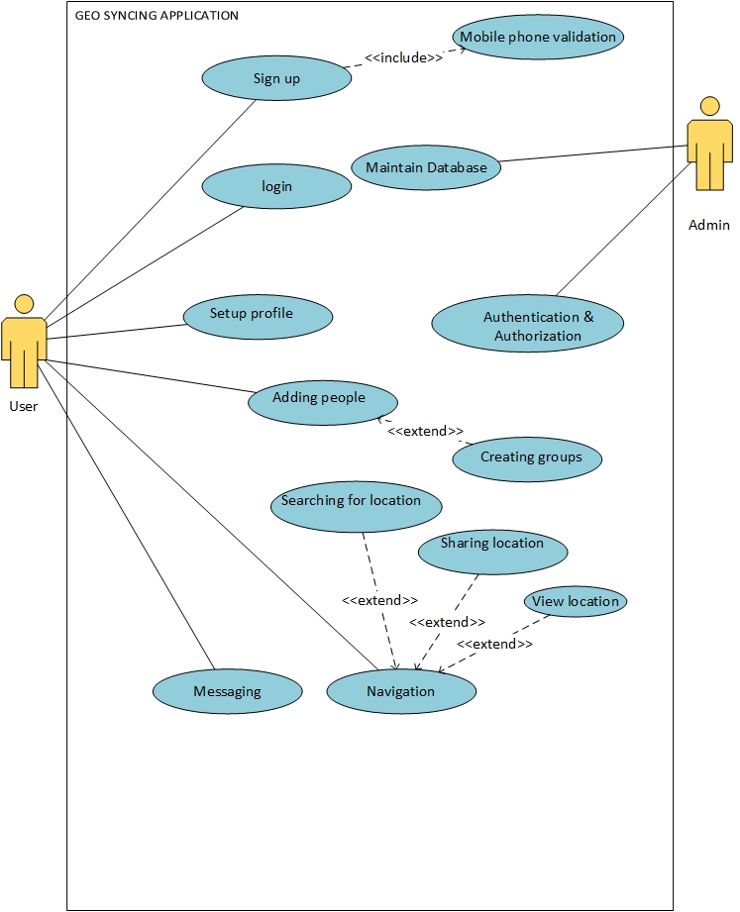
Fig. 2.3 Sample Use case diagram

  - Requirements Analysis
We analyze, refine and scrutinize requirements to make consistent & unambiguous requirements.
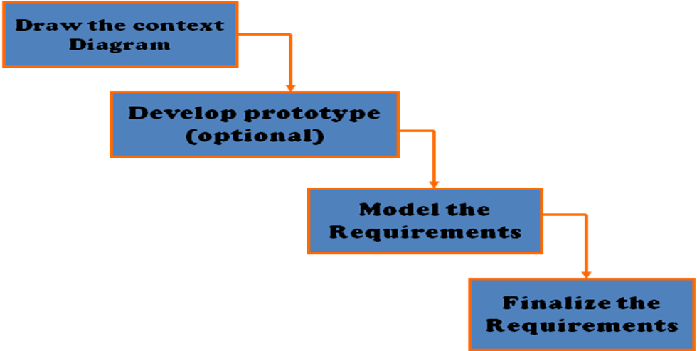
Fig. 2.4 Steps of Requirements Analysis

2.2.1 Context Diagram
The Context Diagram is a simple model that defines the boundaries and interfaces of proposed system with the external world. For example the context Diagram of Student Result Management System is shown below:
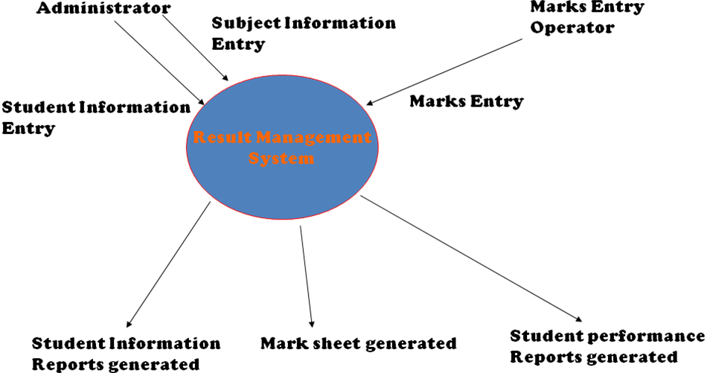
Fig. 2.3 Sample Context Diagram
Note: Students need to Draw Context Diagram

2.2.2 Develop Prototype
One Effective way to find out what the customer really wants is to construct a prototype, something that looks and preferably acts like a part of the system they say they want.
We can use their feedback to continuously modify the prototype until the customer is satisfied. Hence, Prototype helps the client to visualize the proposed system and increase the understanding of requirements. The prototype should be built quickly and at a relatively low cost.
We have different online tools available to develop effective prototype

Note: Students need to develop Prototype
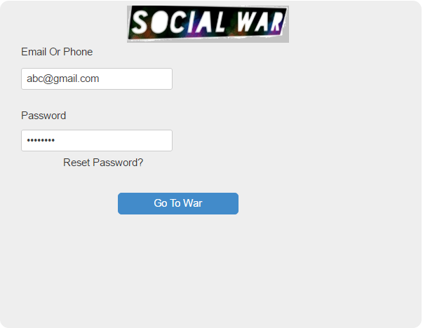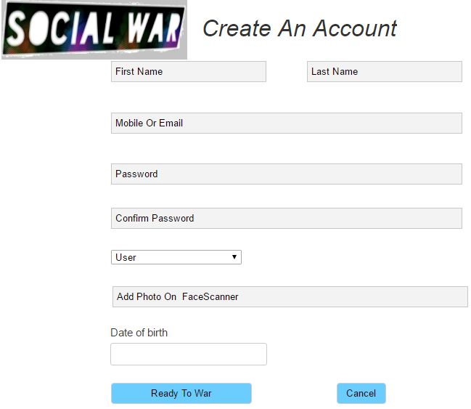
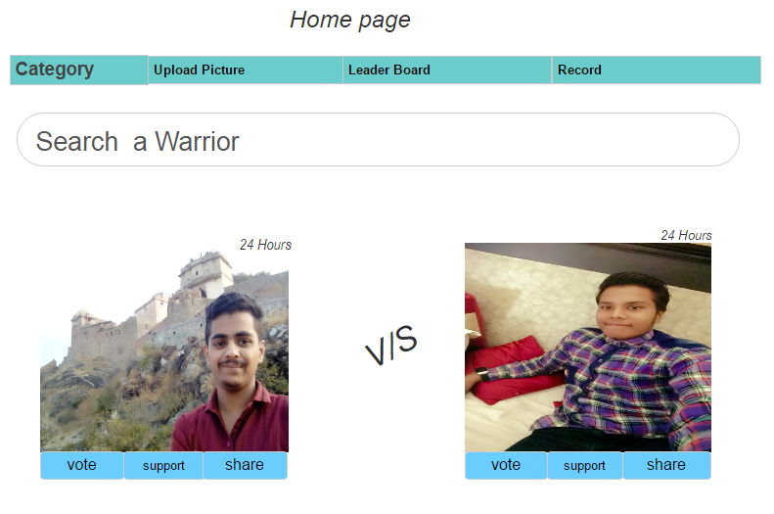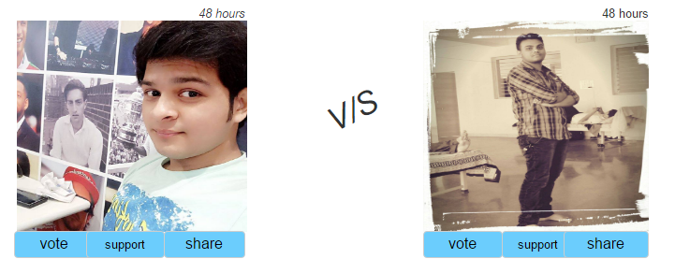

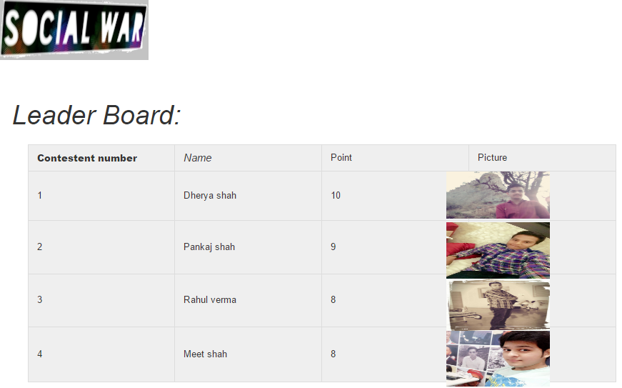

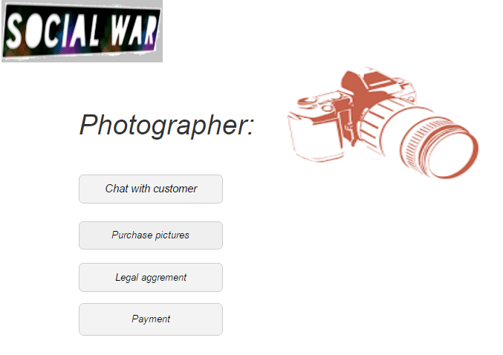

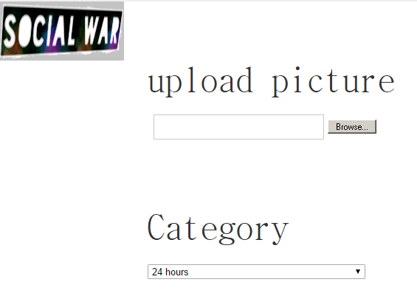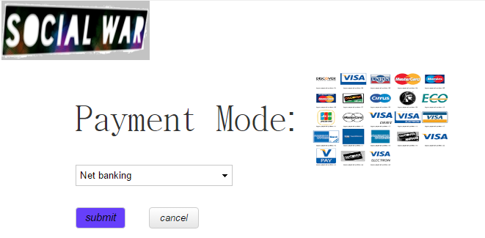

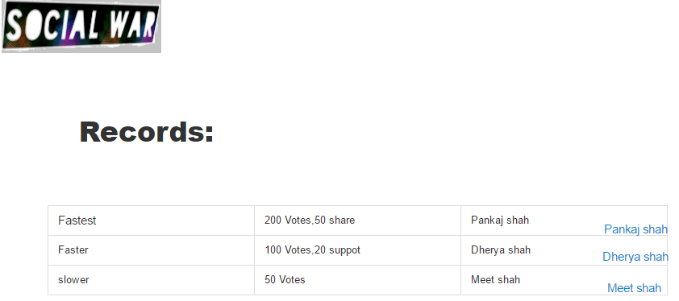

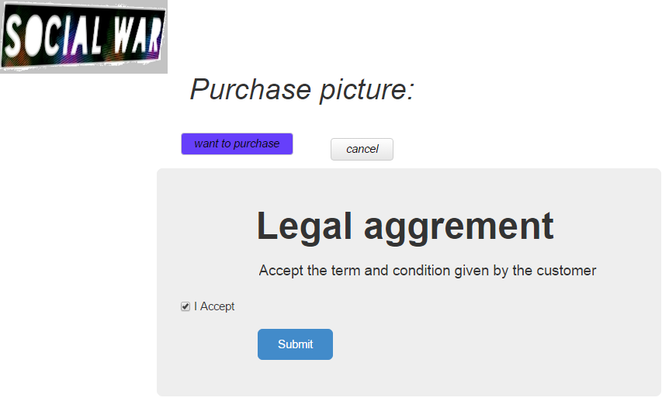

2.2.3 Model and Finalized the Requirements
Data Flow Diagrams (DFD) are used widely for modeling the requirements. DFDs show the flow of data through a system.
The DFD may be used to represent a system or software at any level of abstraction. DFDs may be partitioned into levels that represent increasing information flow and functional details. A level-0 DFD is also called as context diagram (already discussed).
Note: Students need to construct DFDs up to level-2.

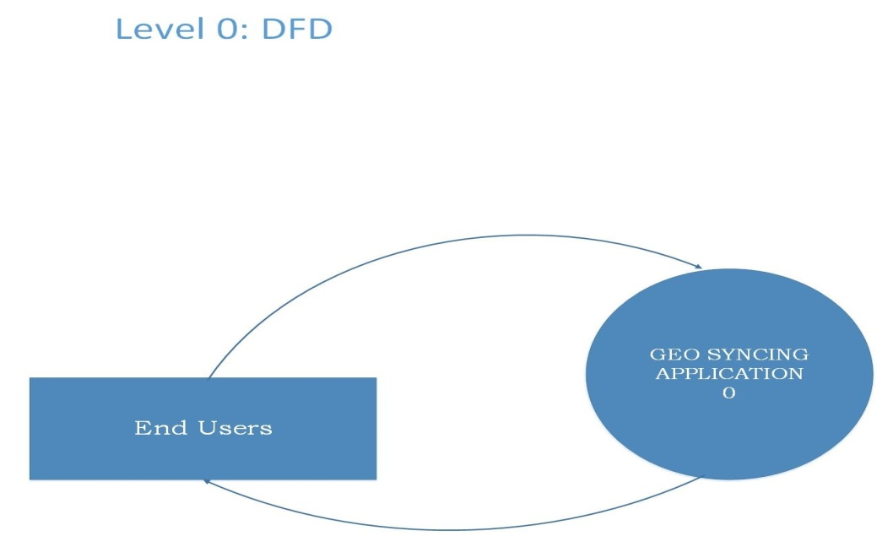

Level 0: Context level diagram

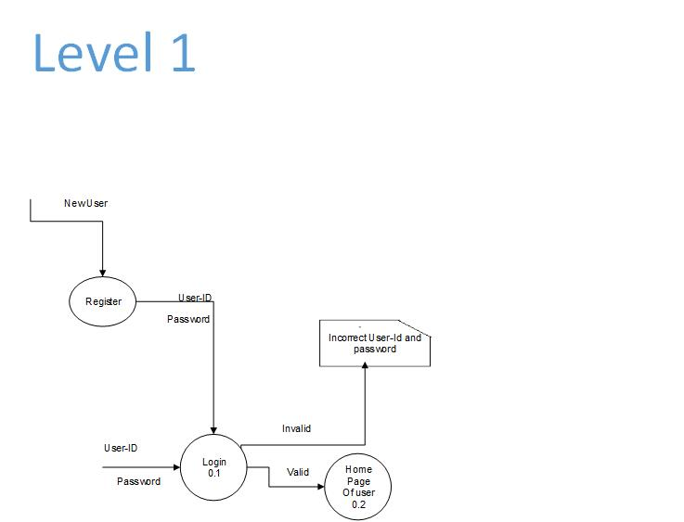
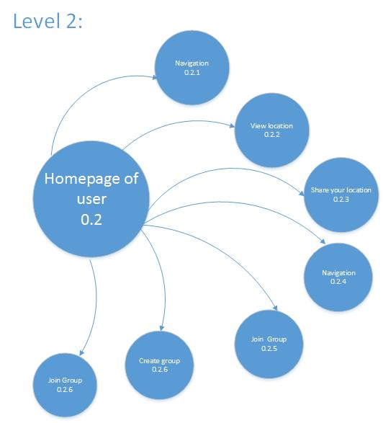

2.3 Requirements Documentation and Requirements Review
Requirements document is called as Software Requirements Specification (SRS). The SRS is a specification for a particular Software Product, program or set of programs that performs certain functions in a specific environment.
Note: Students need to submit Project Report. Format for the report will be given soon.

CHAPTER 3 Conclusion and Future Scope

References

Appendix

/*Body of the dissertation report starts from here onwards */
/* Chapter Title in 16 pts, Bold, Right Justified, Times New Roman, with four line spacing after the
title and before the beginning of the text in para 1. */
/* Each paragraph heading must be 14 pt bold with appropriate index number, with a line space after and before it. Each para subheading must be in 12 pt bold and with subindex as appropriate e.g 2.1 OR 2.1.1 …...
The paragraph text must be in 12 pt, Times New Roman, Full Justified, 1.5 line spacing, with the text printout on BOTH the sides of the page, single side printout will not be allowed */
/* Very importantly note that the pages in the body of the report are NOT having any border, whereas the title pages upto the previous page are having borders.
/* Note that numeric page numbers to these (i.e actual content) pages in the report whereas as can be seen above, the roman letter page numbers are to be given to the TITLE pages i.e. pages upto the previous page */
/* The binding of the report must be TRANSPARENT WHITE/BLUE FRONT COLOR AND BLACK/BLUE COLORED REAR/BACK SPIRAL BINDING only */
Information Gathering Form
PROTOTYPE DESIGN (2nd Year/4th Semester)
Month:_______________2017

NAME :
ENROLLMENT NO:
Project Work Progress & Activities
Week 1
Date | Activities | Report Progress | Review/Remark | Guide Sign
Week 2
Date | Activities | Report Progress | Review/Remark | Guide Sign
Week 3
Date | Activities | Report Progress | Review/Remark | Guide Sign
Week 4
Date | Activities | Report Progress | Review/Remark | Guide Sign
Faculty Guide
Asst. Prof. ___________________________
CSE Dept., PIT/PIET (2nd Shift)
Tentative Schedule
Sr. No. | Task | Date
1 | Problem Definition and Use Case Diagram | 3rd April to 7th April, 2017
2 | Prototype and DFD | 24th April to 28th April, 2017
3 | Final Report | 3rd May to 7th May, 2017

.

Problem Definition Form
Work Report
Status for | Date | Progress | Marks | Guide Sign
Week 1
Week 2
Week 3
Week 4

Activities
Week 1
Week 2
Week 3
Week 4

Guidance for PPT Format

Slide 1 | Slide 2
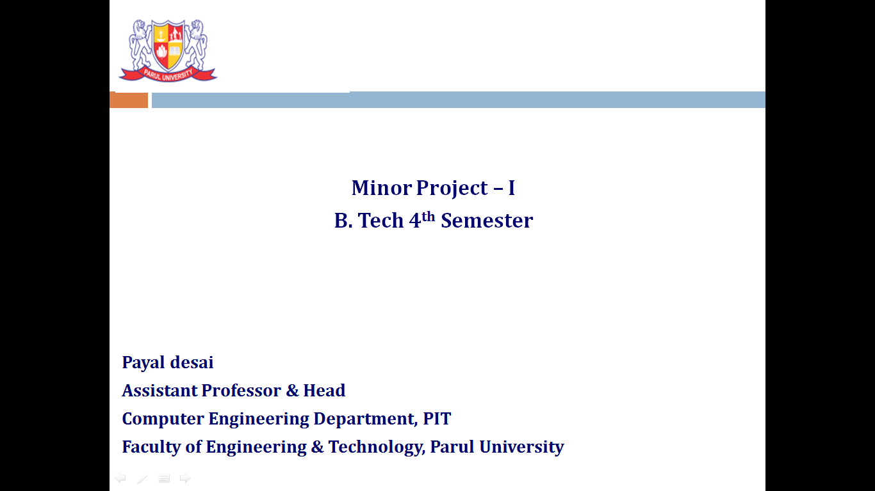 | 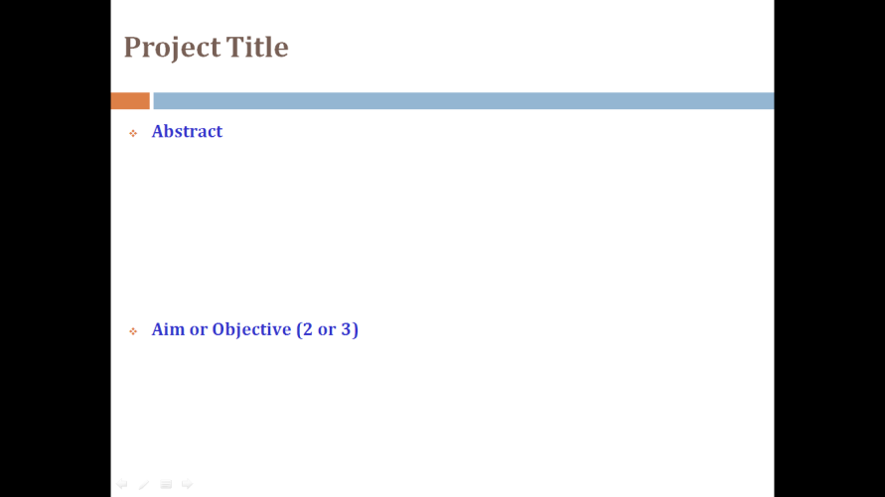
Slide 3 | Slide 4
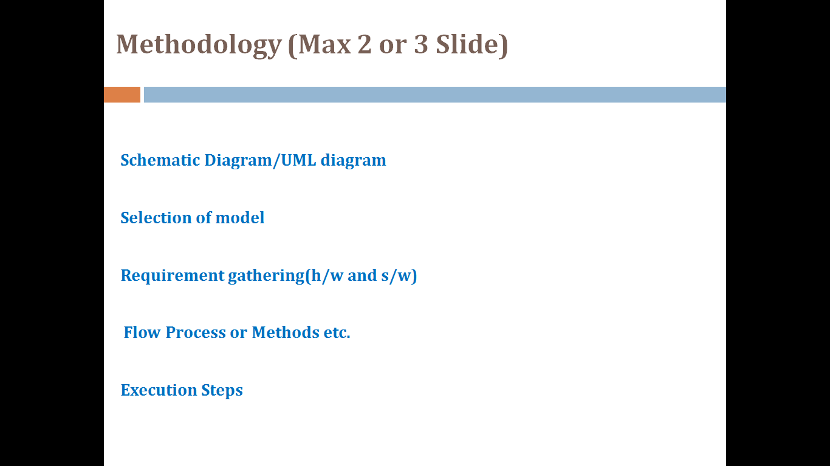 | 